4.5 I can archive the outcomes of collaborative working

When working on a collaborative project one must archive things, by law. Companies have a duty archive work of others when they have finished them and no longer need them or if the project is a failed project.

Even some sites are archived and they can be accessed publicly. Wayback Machine is one of those 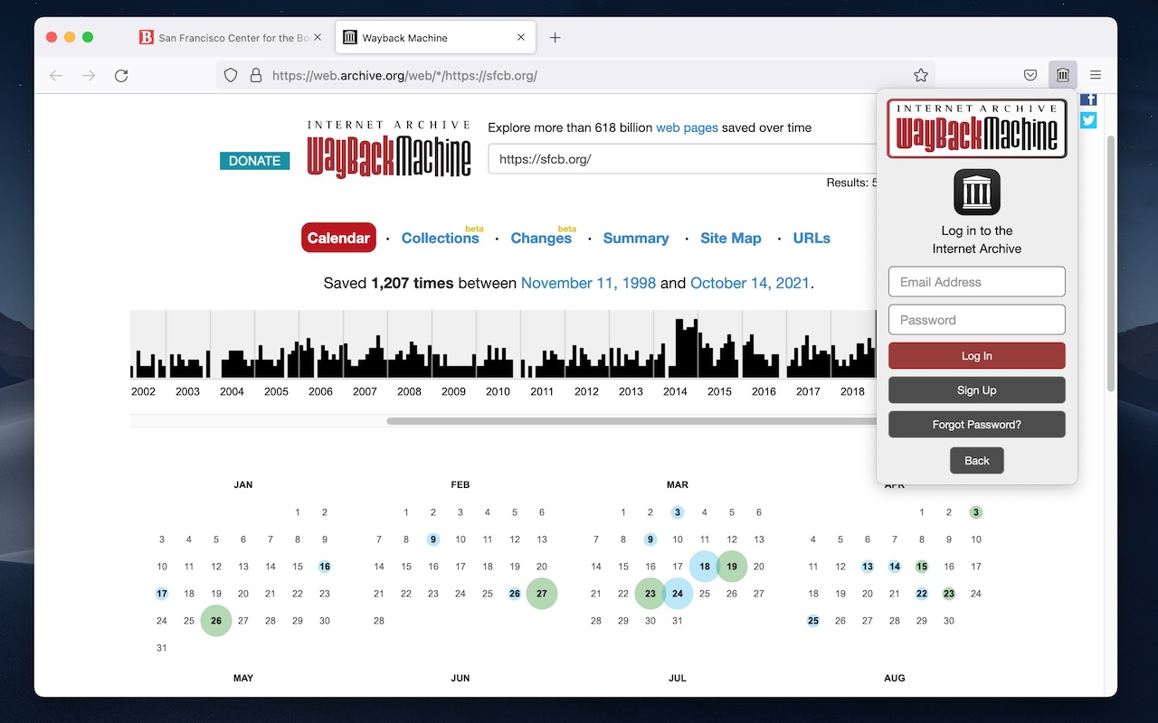extensions that allow people to do this:

[The above image shows a screenshot of the Wayback Machine]

Schools and other educational institutes have a duty to archive their students work but professional instances like sharing on Github have places to share archives of older versions of the published p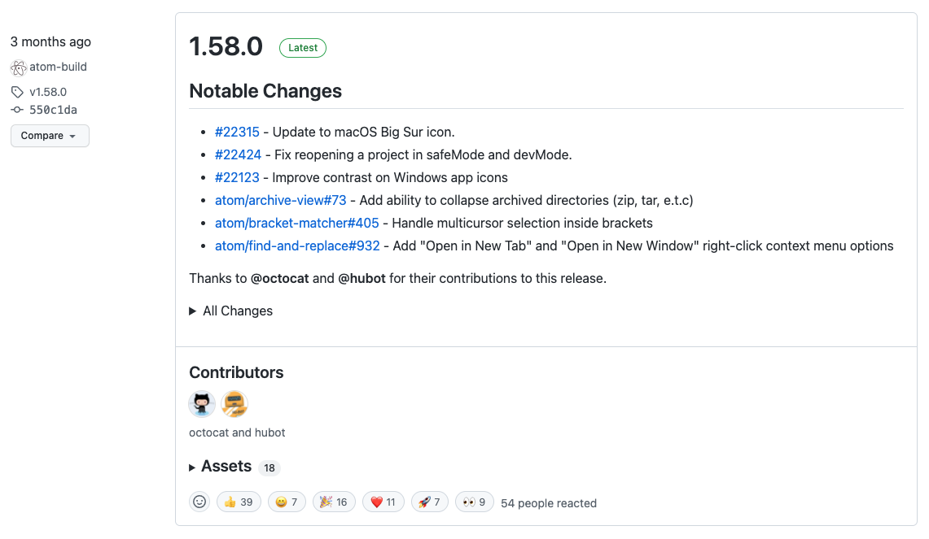roject.

[The above image is an example of a Github version]